**Common Gardening Mistakes to Avoid for Beginners**

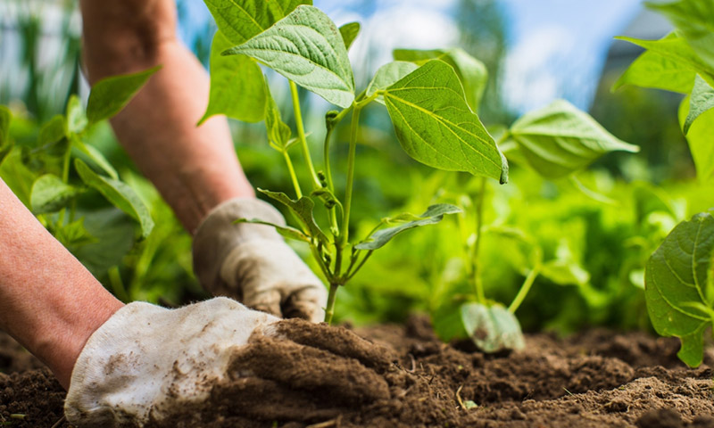

Gardening is an art that requires attention to detail and a love for nature. However, we often make seemingly harmless mistakes that can have significant consequences for the growth of plants. Let’s explore some of the most common gardening mistakes that beginners often make in this article from **Green Groves**!

**Mistakes to Avoid in Gardening**

**1. Not Preparing the Soil**

One of the most common mistakes among beginners is failing to check and prepare the soil before planting. The soil needs to be nutrient-rich, well-draining, and capable of retaining water. Unprepared soil is often too hard and dense, making it difficult for plant roots to penetrate. This reduces the plant's ability to absorb water and nutrients, leading to poor growth and malnourishment.

If the soil is not prepared, air circulation within it will also be limited, causing waterlogging and a lack of oxygen, which can harm the plant’s root system and result in poor growth and yellowing of the plant. Additionally, unprepared soil typically has poor water retention, causing water to drain away too quickly from the root zone, leaving the plant vulnerable to dehydration, especially during hot and dry conditions.

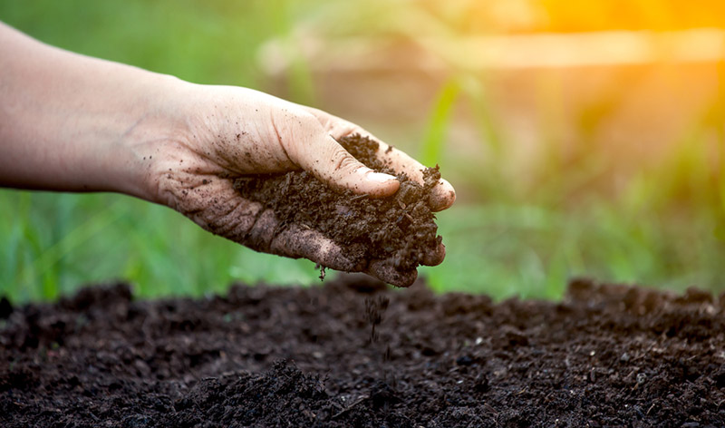

Soil that isn’t prepared can also reduce plant yield, as it doesn't provide enough nutrients. Moreover, it can harbor pests and diseases that may negatively affect plant health, requiring frequent intervention to control them.

**2. Lack of Sunlight**

A lack of sunlight is a significant concern in gardening. Sunlight is not only the energy source for plants but also a crucial factor in their growth and resistance.

When plants don’t get enough light, their leaves may become thin, flexible, lose their natural green color, or even turn yellow or red. This indicates that the plant is weakening due to insufficient light for photosynthesis.

The plant may also grow unevenly, with parts of it trying to reach the nearest light source. This can result in an unbalanced plant that looks misshapen and unattractive.

For plants that require a lot of sunlight to flower and fruit, such as fruit trees, lack of light can prevent blooming and fruit production, negatively impacting yield and product quality.

**3. Overwatering**

Overwatering can cause several problems for plants, such as:

* Soil that retains too much water for too long, damaging the roots. Roots need to be exposed to air to breathe, and excessive water can block this process, causing root rot.
* Waterlogged soil reduces oxygen availability in the soil. Plants need oxygen for respiration and nutrient conversion. When oxygen levels drop, plants become weak.
* A damp environment is ideal for mold and bacterial growth, which can severely damage the plant.
* Leaves may change color and fall off prematurely, while fruits may crack or rot.

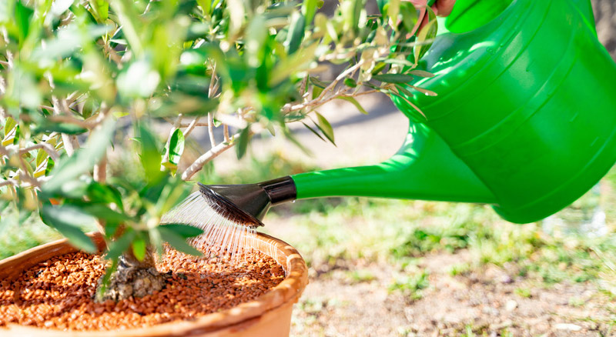

**4. Using an Incorrect Pot Size**

Choosing the wrong pot size can lead to many issues for plant growth. If the pot is too small, it can restrict the plant’s ability to grow, as there won’t be enough space for the roots, branches, or leaves to expand, causing the plant to become weak, malnourished, and poorly hydrated.

A small pot also means the drainage holes may be inadequate, causing excess water to accumulate, leading to waterlogging that harms the root system. The plant becomes weak and more susceptible to pests and diseases.

Furthermore, using a pot that’s too small can make the plant look unbalanced, which affects the aesthetic value of your space.

**5. Over-fertilizing**

A common mistake many gardeners make is over-fertilizing. While fertilizing is crucial for plant care, applying too much can lead to various problems. When too much fertilizer is used, the plant cannot absorb all the nutrients, resulting in excess fertilizer accumulating in the soil, which can cause damage.

One common consequence is root burn, as the plant absorbs too much salt from the fertilizer, making it harder for the plant to take in water and nutrients. Excess fertilizer can also pollute the environment if it runs off into nearby water sources, causing damage to ecosystems.

Therefore, fertilizing should be done carefully and according to the product’s instructions, avoiding overuse and ensuring that the plant gets the right amount of nutrients without causing harm.

**6. Neglecting Pruning**

Neglecting proper pruning is a frequent mistake in gardening. Plants need maintenance, and pruning is an essential part of their care.

If branches aren’t pruned, the plant may lose its aesthetic value and fail to grow optimally. Competing branches may block each other from light and space, which reduces the plant's overall performance.

In addition, not pruning can provide a conducive environment for pests and mold. Hidden areas in the plant become ideal places for them to hide and grow.

However, pruning must be done carefully. If you cut too aggressively or incorrectly, it can harm the plant’s resistance and make it more susceptible to diseases or death.

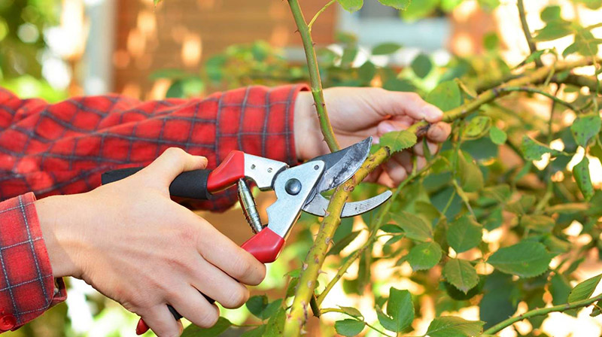

**7. Ignoring Pest and Disease Prevention**

Neglecting pest and disease prevention can lead to severe issues for the development of your plants and their resistance. This can result in unwanted consequences, such as:

* Pests and diseases can destroy or weaken plants, leading to poor harvests or loss of crops.
* Pests can spread quickly throughout the garden if not controlled in time. One infected plant can become the source of an infestation for the entire garden.
* Poor harvests or failed crops can cause significant economic losses for gardeners.
* Once pests have entered, controlling them might require harmful chemicals that can damage both the plant’s resistance and the environment.
* Some pests can cause so much damage that the plant can’t recover, ultimately leading to its death.

**Conclusion**

Gardening is a wonderful passion, but to make your dream a reality, it’s essential to learn and avoid common mistakes. Always pay attention to your plants’ resistance, provide enough light, water properly, choose the right pots, fertilize carefully, and most importantly, stay vigilant with pest prevention. With the right approach, you can create a lush, beautiful garden full of life.